**

***LAB # 05***

*To sort a linear array using Selection Sort, Bubble Sort and Merge Sort.*

November 4, 2024

**

***LAB TASKS***

***TASK # 01***

1. Write a program for Selection sort that sorts an array containing numbers, prints all

the sort values of array each followed by its location.

*INPUT*

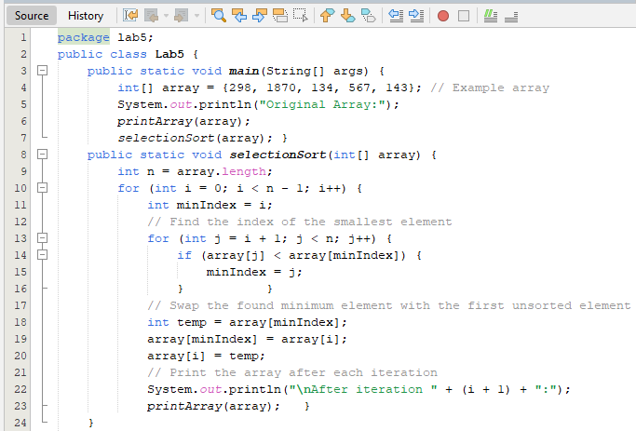

**

*OUTPUT*

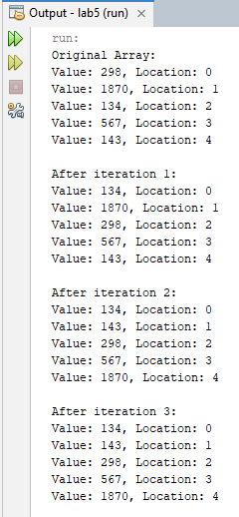 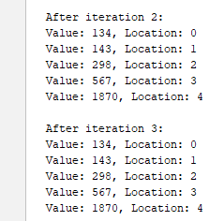

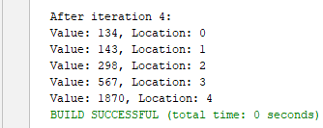

***TASK # 02***

Write a program that takes 10 numbers as input in an array. Sort the elements of array

by using Bubble sort. Print each iteration of the sorting process.

*INPUT*

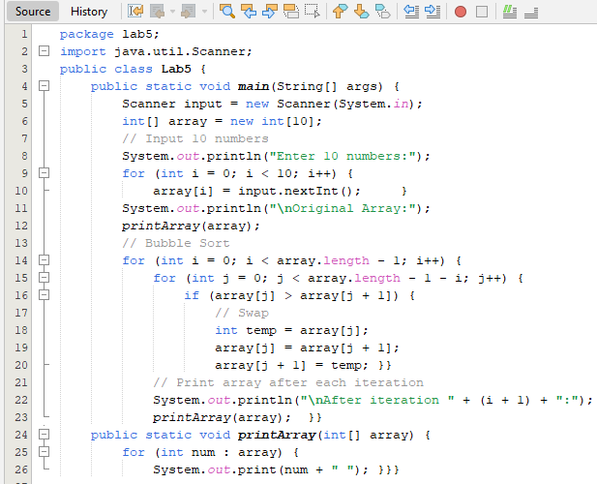

*OUTPUT*

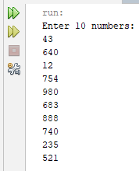

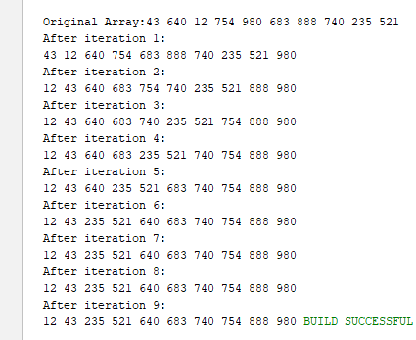

***TASK # 03***

*Write a program that takes 10 random numbers in an array. Sort the elements of array*

*by using Merge sort applying recursive technique. Print each iteration of the sorting process.*

*INPUT*

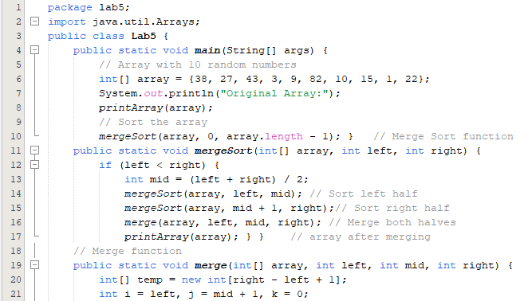

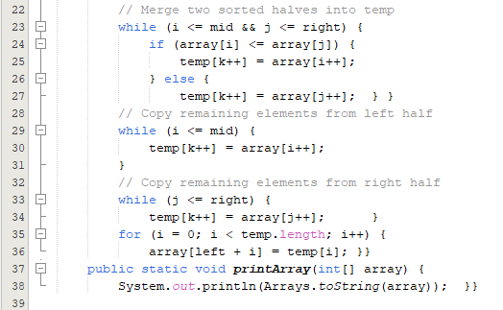

*OUTPUT*

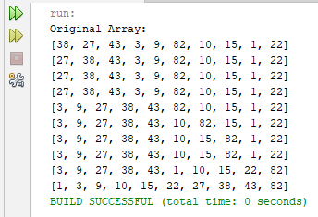

***HOME TASKS***

***TASK # 01***

Declare an array of size n to store account balances. Initialize with values 0 to 100000 and sort Account No’s according to highest balance values by using Quick sort, For e.g.:

Account No. 3547 Balance 28000

Account No. 1245 Balance 12000

*INPUT*

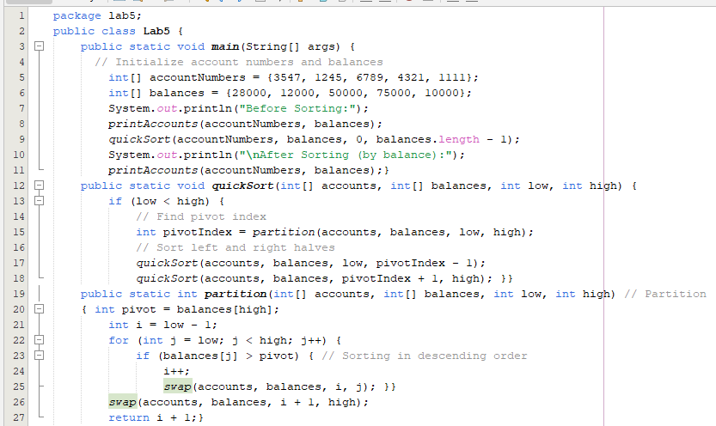

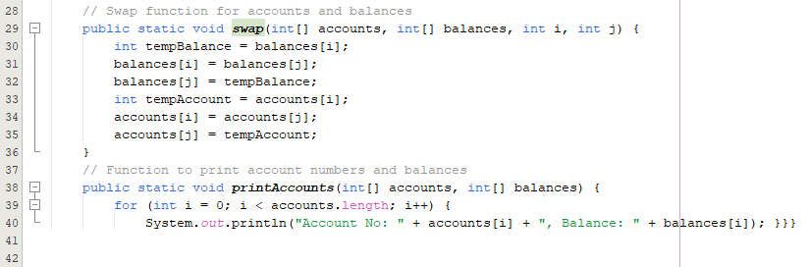

*OUTPUT*

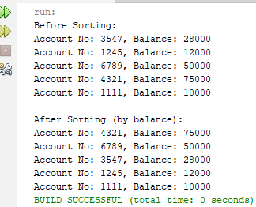

***TASK # 02***

Write a program which takes an unordered list of integers (or any other objects e.g. String), you have to rearrange the list in their natural order using merge sort.

*INPUT*

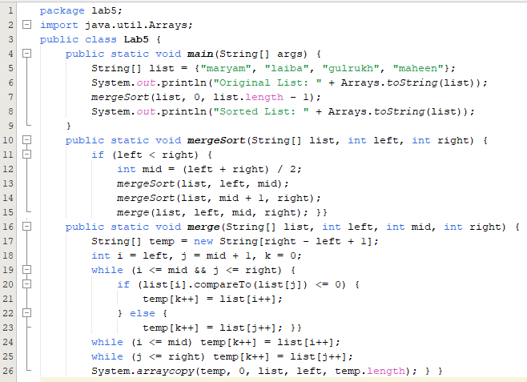

*OUTPUT*

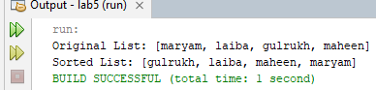

***TASK # 03***

You are given an unordered list of integers or strings. Write a program to Take this list as input. Sort it in **natural order** using Merge Sort. For integers, this means ascending order. For strings, this means alphabetical order. Print the sorted list.

*INPUT*

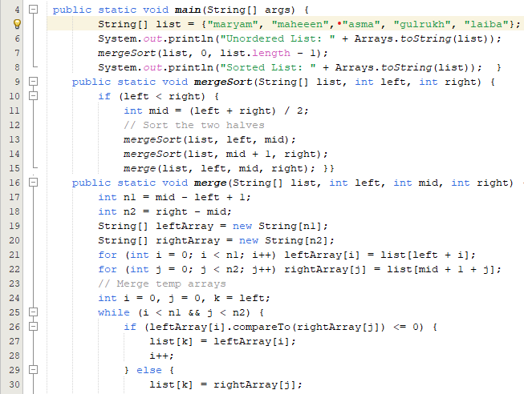

*OUTPUT*

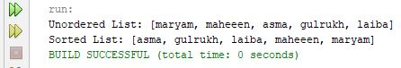

***TASK # 04***

You are given a set of bank accounts, each with a unique account number and a balance. Write a Java program to Declare an array of size n to store account balances. Initialize each balance randomly with values between 0 and 100,000. Sort the accounts in **descending order** of their balances using Quick Sort. Print the sorted list in the format

.

*INPUT*

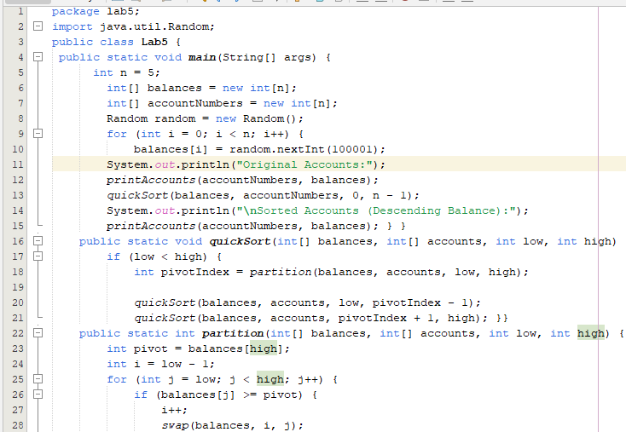 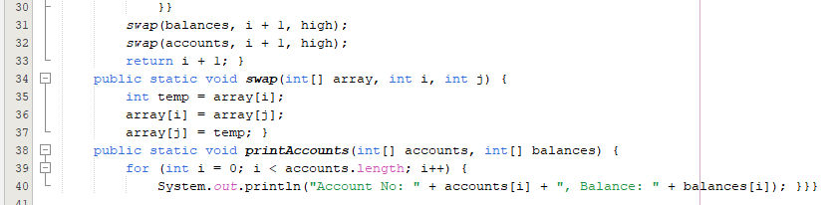

*OUTPUT*

